*Florida International University*

*School of Computing and Information Sciences*

Software Engineering Focus

Feature Document

User Story ID #1004

**Name: Search User**

**Team Member: Alvaro Silva**

**Project: SkillCourt 7.0**

**Product Owner(s)**: Guðmundur Traustason

**Mentor(s)**: Masoud Sadjadi

**Instructor**: Dr. Masoud Sadjadi

**Search User:**

* Description: **As a** User **I would like** to search the user **so that** I can select a user and send invitations to it.

Acceptance Criteria

* Users have a SkillCourt account.
* Challenger user has a FCM Registration ID available in the database.

**Use Case**

* Name: Search User
* Actor: Challenger
* Preconditions: Challenger has an account with SkillCourt ***and***

challenged has an account with SkillCourt.

* Description <Flow of events>:

|  |  |
| --- | --- |
| Actor Steps | System Steps |
| 1. Actor clicks in Challenge Player button. |  |
|  | 2. System opens search screen. |
| 3. Actor add email in the search input field. |  |
|  | 4. System search in the database the user with that email. |
|  | 5. If system founds a user with that email, System displays the email of the user in the UI. |
| 6. Actor clicks in the email of the user |  |
|  | 7. System search in the database the Registration ID of the user. |
|  | 8. System save the Registration ID of the user. |

**Use Case Diagram**

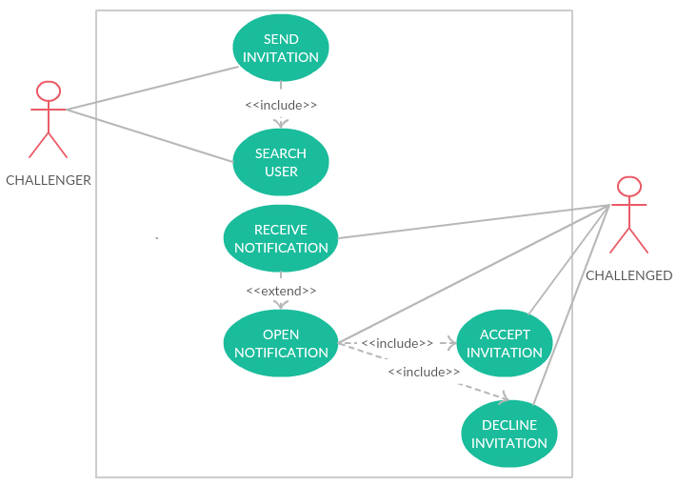

**Sequence Diagram**

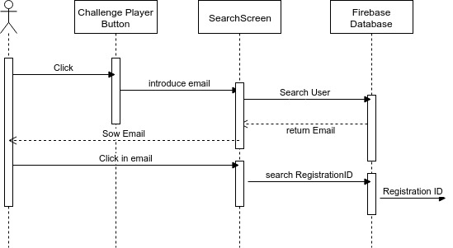

**Unit Test**

* Test case ID:
* Description/Summary of Test: Test if the implementation for searching the user works.
* Pre-condition: SkillCourt app running.
* Expected Results: Search the user in database, and if it exists, returns the Registration ID.
* Actual Result: Found the user in the database and returns the correct Registration ID.
* Status (Fail/Pass): Pass.

**Visual User Guide**

